

**Provisioning Template to Create VIP with partition & route domain**

**User Guide**

|  |  |  |
| --- | --- | --- |
| **Version** | **Remarks** | **Date** |
| **1.0** | **Provisioning Template User Guide for Create VIP with partition & route domain.** | **18/01/2017** |
| **2.0** | **Updated document with installation of the template.** | **14/02/2017** |
| **3.0** | **Updated document to mention about required python package & configurational parameters** | **27/03/2017** |
|  |  |  |

## Installation of the Template and Helper Script

1. Login to AppViewX.
2. On the left navigation menu, select ***Provisioning***; and click ***Template.***
3. On the upper right portion of the screen click on the  Import button.
4. The following screen will appear. 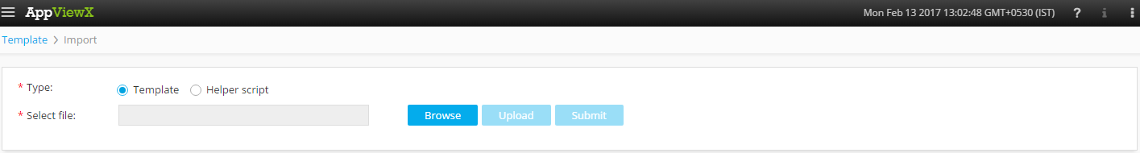
5. Please Select Template/Helper Script.  
   If Template is chosen,
   1. Click on *Browse* and select the Zip File of the template which has to be installed/imported and click open.
   2. Click on upload to import the Zip file and display the templates present in the zip file.
   3. Click on submit to deploy the templates into the AppViewX Environment.

If Helper Script is chosen,

1. Click on *Browse* and select the Zip File of the Helper script which has to be installed/imported and click open.
2. Click on upload to import the Zip file and display the Helper Scripts present in the zip file.
3. Click on submit to deploy the Helper Scripts into the AppViewX Environment.

6. Transfer and unpack the file “suds.tar.gz” into “/home/appviewx/AppViewX/aps/dependencies” folder.

## 2. Configurational parameters

1. On the left navigation menu, select *Provisioning*; and click *Template.*
2. Click helper script on the top right corner *C:\Users\hariprasaad.d\Desktop\helper.png*
3. Look up for helper scripts from the below tabular and modify the parameters

|  |  |  |
| --- | --- | --- |
| **SCRIPT NAME** | **PARAMETER** | **DESCRIPTION** |
| bluecat_soap_connector | BASE_CONFIGURATON | Name of the Configuration object in Bluecat IPAM system |
| bluecat_soap_connector | BASE_VIEW | Name of the DNS View object in Bluecat IPAM system |

## 3. Create VIP with PARTITION AND ROUTE DOMAIN.

1. Login to AppViewX.
2. On the left navigation menu, select ***Provisioning***; and click ***Request.***
3. On the upper right portion of the screen, click the  ***Create*** button.
4. Select the provisioning template name from the list –‘**Create_VIP_Route_domain_Template_V1**’.

**Note:** *If no template is available, this indicates that the user role does not have permission to the requesting template.*

1. Enter the provisioning request description – ‘*Create VIP with partition & Route Domain*’.
2. Add a default Request scenario name relevant to the template. ***E.g***.: VIP creation on F5 ADC.
3. Click on ‘***Get Device List***’ button to fetch the available list of F5 devices in the inventory.
4. In the **Device** field, list of F5 devices are populated. Please select the **F5** device on which the VIP with partition & route domain has to be created.
5. Click on ‘***Get Route Domain***’ button to fetch the list of available route domains in the inventory.
6. In the **Route Domain** field, list of the available route domains are populated based on the *F5* *Device*. Please select the route domain.
7. Click on ‘***Get Partition***’ button to fetch the list of available partitions in the inventory.
8. In the **Partition** field, list of the available partitions are populated based on the *F5 device*. Please select the partition. ***E.g***.: Common.
9. If the IP has to be fetched from the *Infoblox* IPAM system, select ***yes*** in the ‘***Integrate with Infoblox IPAM****’* field.
10. Click on the ‘***Get Infoblox devices****’* button to fetch the IPAM devices from the inventory.
11. Please enter the *subnet* in the **Subnet** field and click on ‘***Reserve Free IP****’* button.
12. If Infoblox IPAM integration is not required, select **No** in the ‘***Integrate with Infoblox IPAM’*** field.
13. Enter the *IP* and *Port* in the respective fields and click on ***Get Details.***
14. Select the *Persistence profile* from the list of available profiles in the **Persistence** field.
15. Specify if *HTTP Profile* has to be created from the **Create HTTP Profile** field and subsequently selecting the ***Defaults from****.*
16. Specify if *HTTP Monitor* has to be set-up. If yes, the following fields need to be entered.

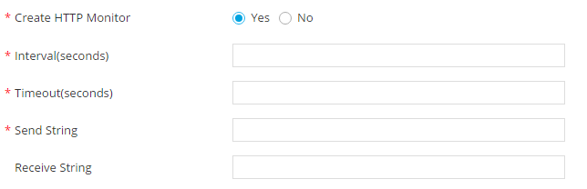

1. Existing monitors can be applied to the Virtual Server by selecting any existing monitor from the ***Use Existing Monitor*** drop down list.
2. The load balancing algorithm can be selected from the ***Load Balancing Method*** drop down list.
3. *Pool Member IP* and *Pool Member Port* can be added and by clicking on the  button, the specific Pool members can be added to the tabular for associating to the Virtual Server.
4. Click  Button; ensure that the Scenario is displayed on the right hand pane.
5. Click on *Submit* to generate work order(s) for the provisioning request.